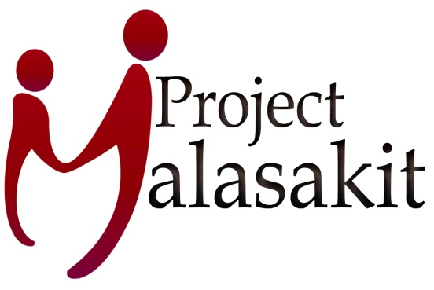
Rm. 142 UP Alumni Center, Magsaysay Avenue, UP Diliman, QC

Telephone number: 09175973432
karapatria@gmail.com; marjorievoriel@gmail.com
www.projectmalasakit.ph

Project Malasakit Accomplishment Report
January-October 2017

2017 was a year of hard work and meaningful projects for Project Malasakit.

Our biggest donor for the year was the 2016 Help2Help Program of BNP Paribas. With total funds amounting to 209,000 pesos which we received early 2017, we were able to build a modern health care facility for the Aeta tribe in Floridablanca, Pampanga.

BEFORE | AFTER
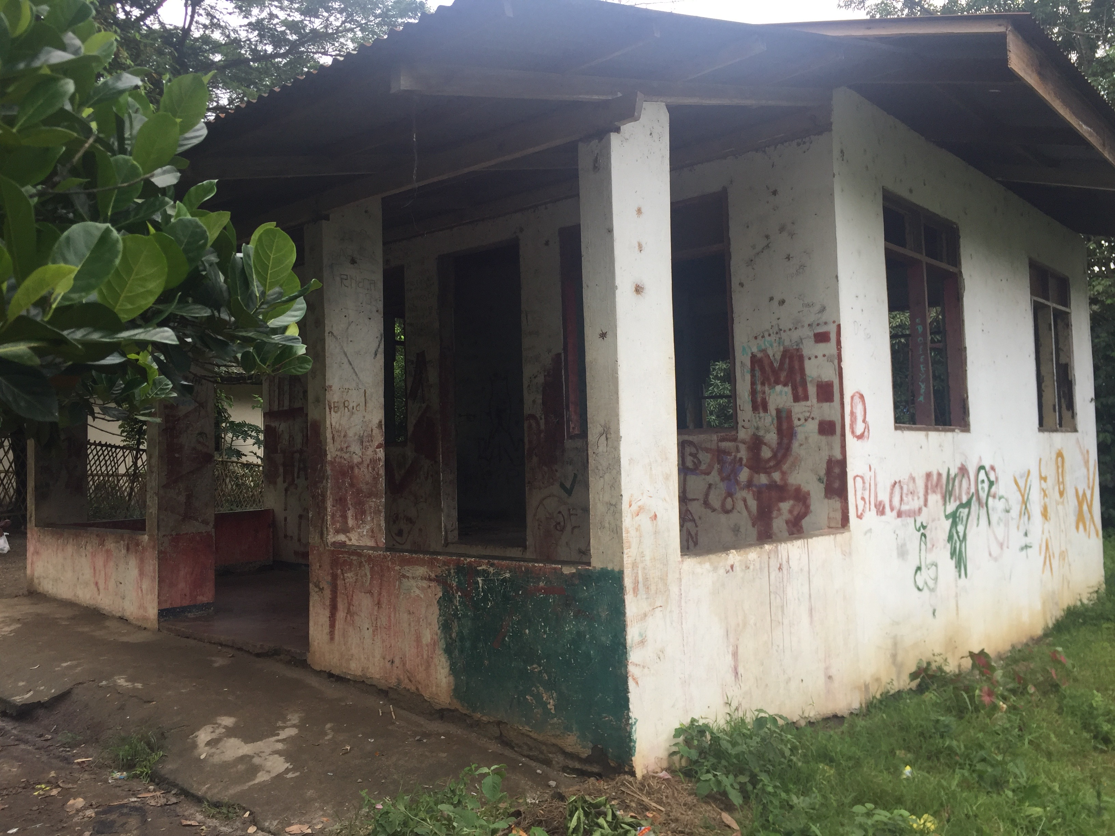 | 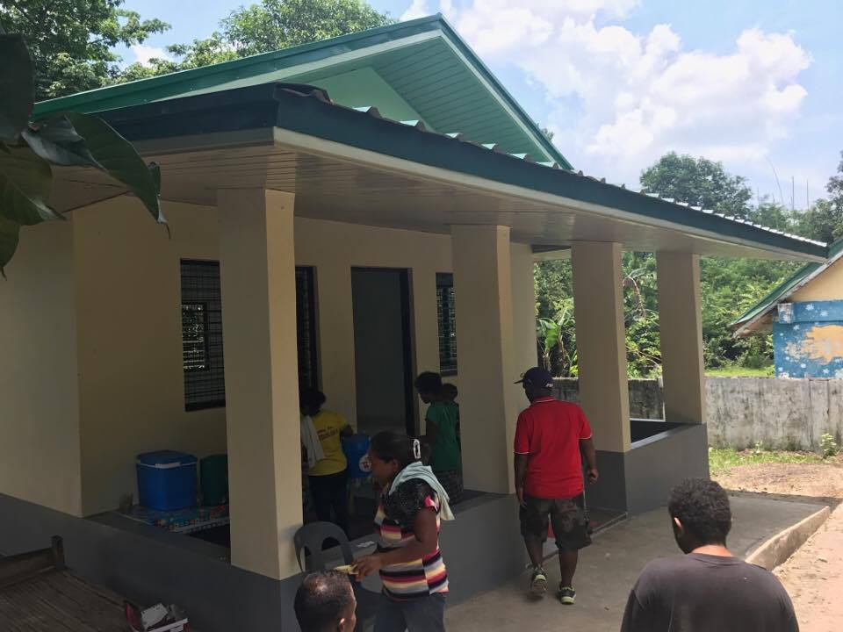
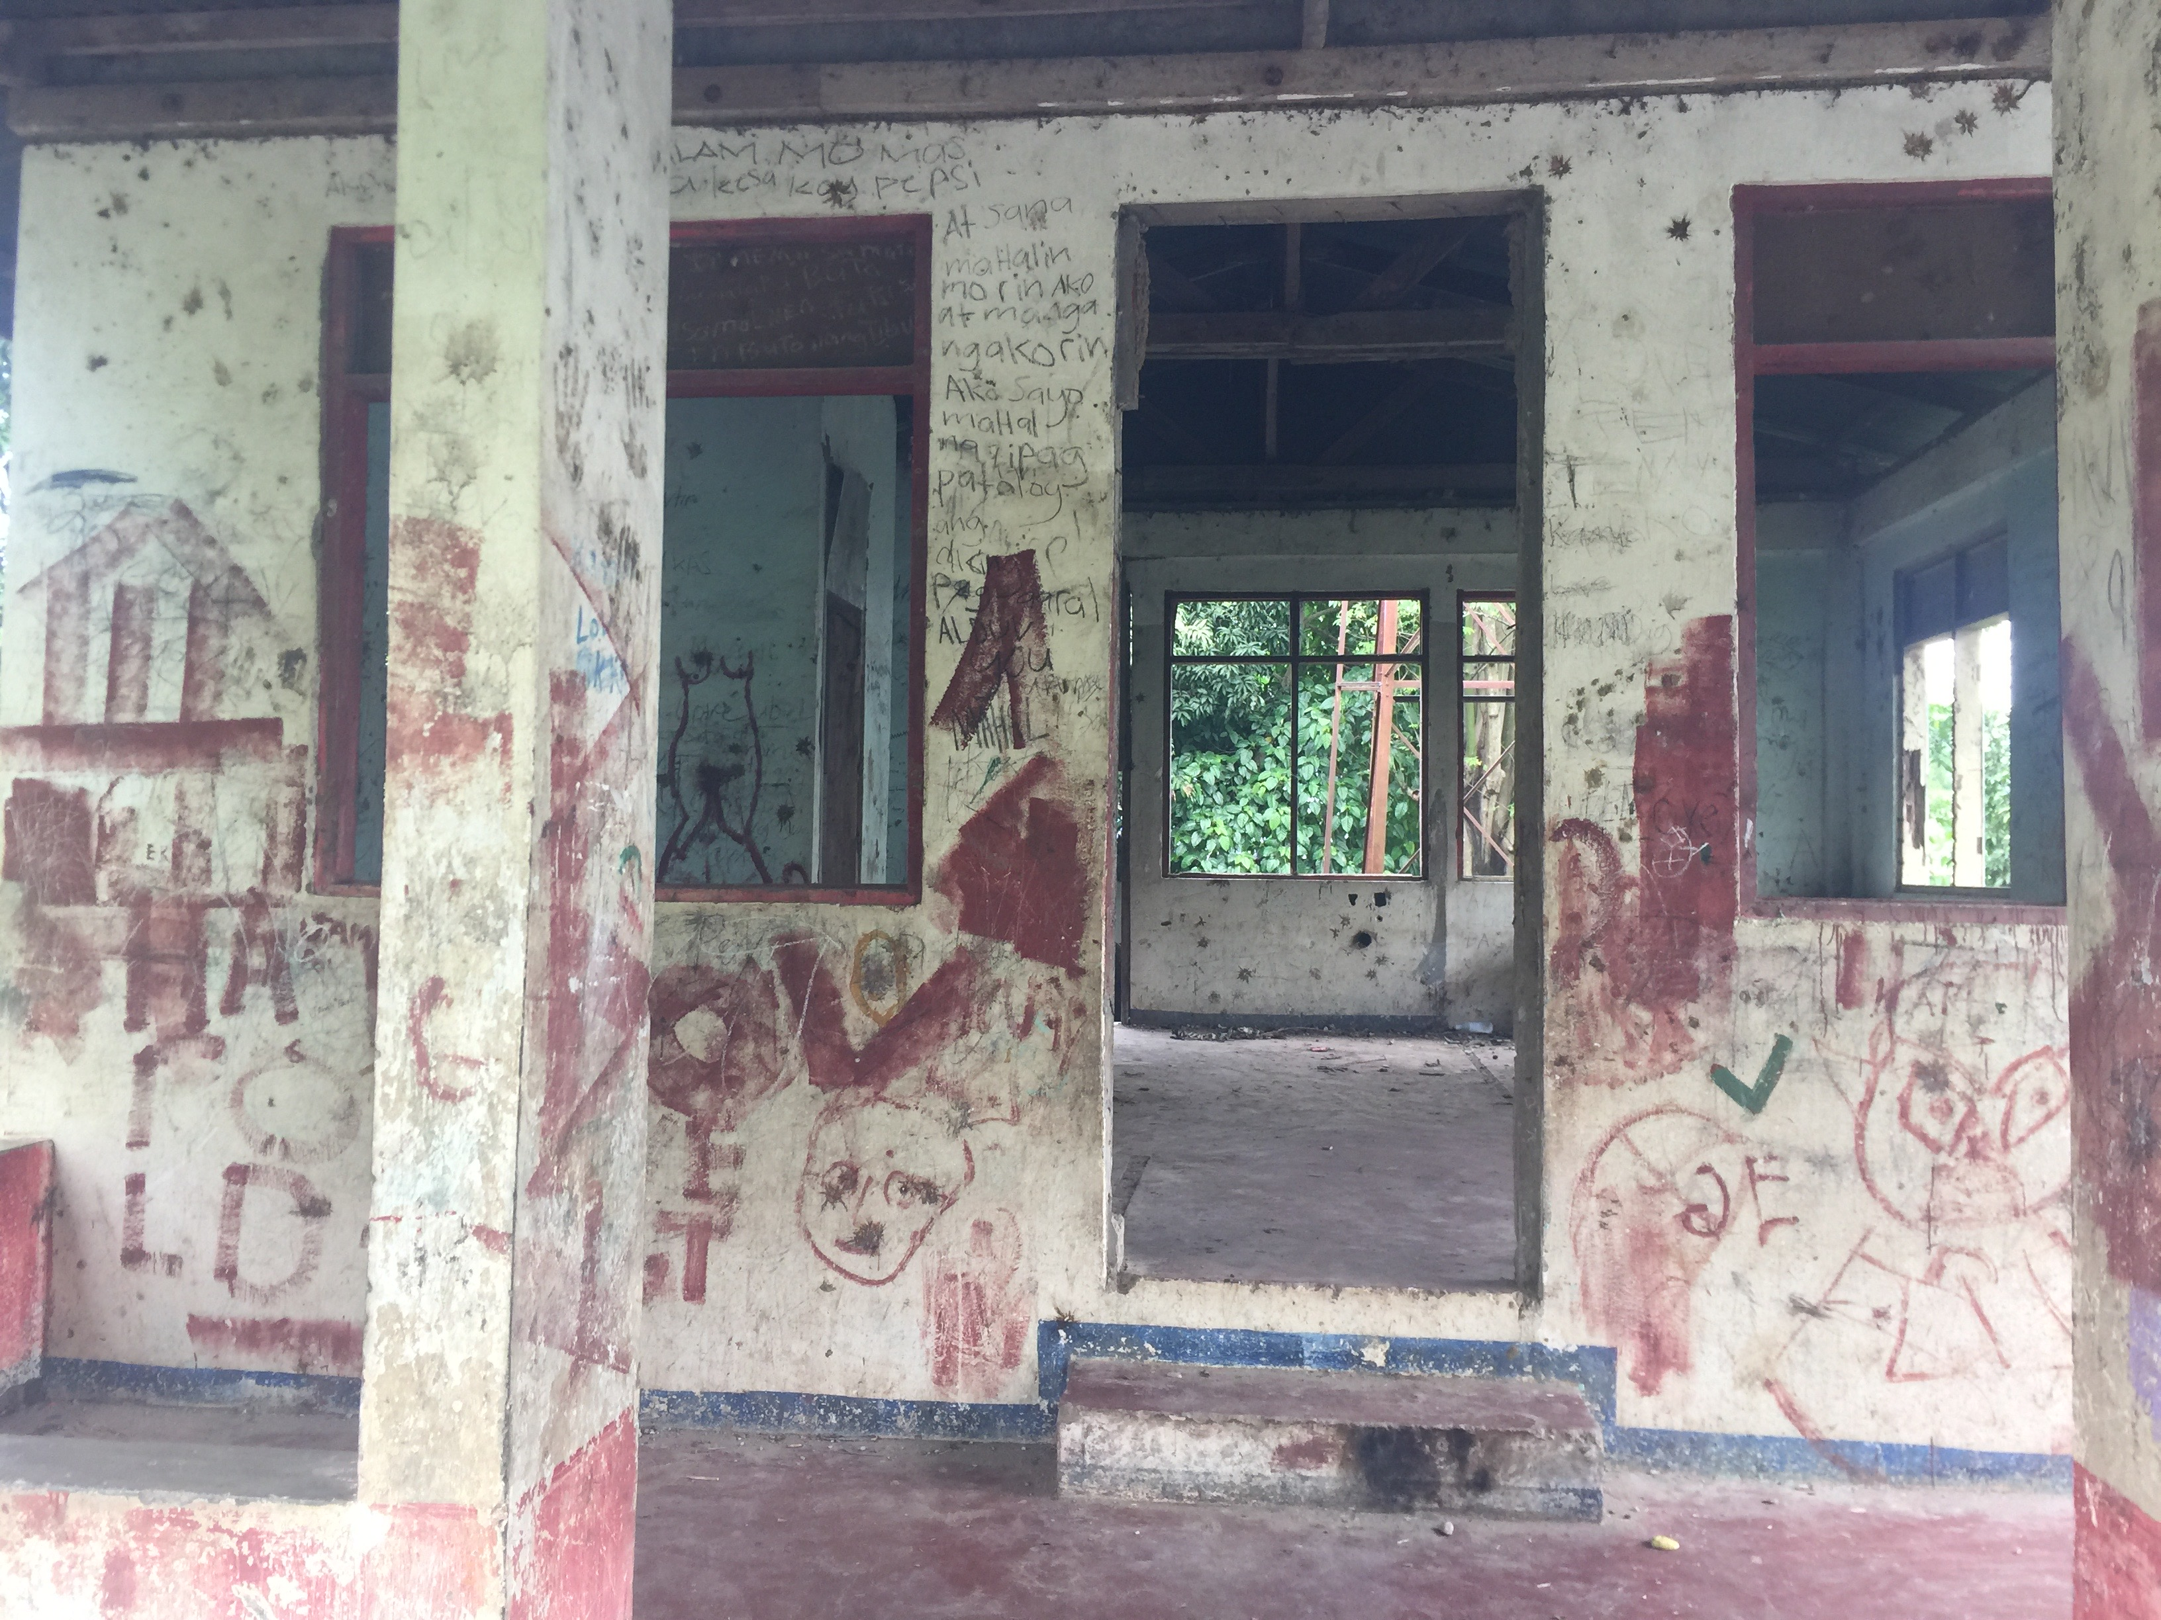 | 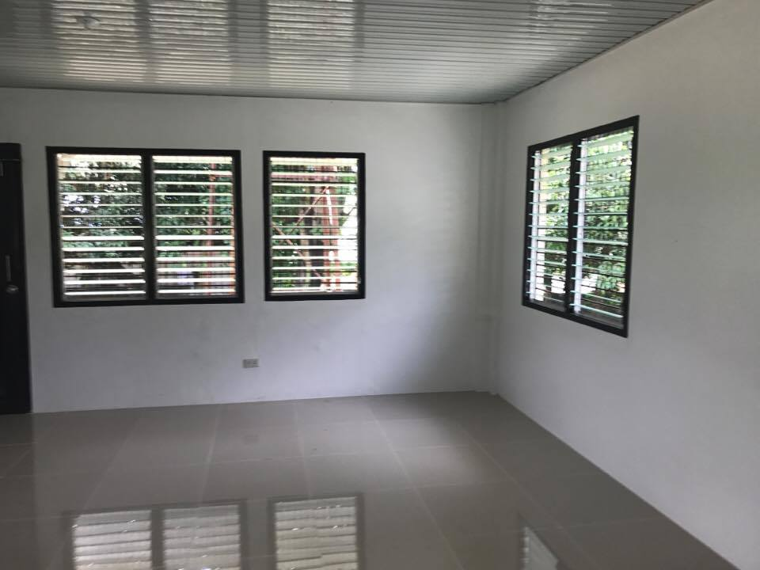

Because of its distance from the lowlands, Sitio Camachile lacks access to basic government services. It does not have any health center nor daycare center. Infant and maternal death is very high because one has to go down the mountain just get medical help. The Philippine Government built a health center in the area way back in the 1980s but now it is so old and dilapidated. We used the funds donated by BNP Paribas to renovate and completely overhaul the structure and make it into a functional, modernized health facility.

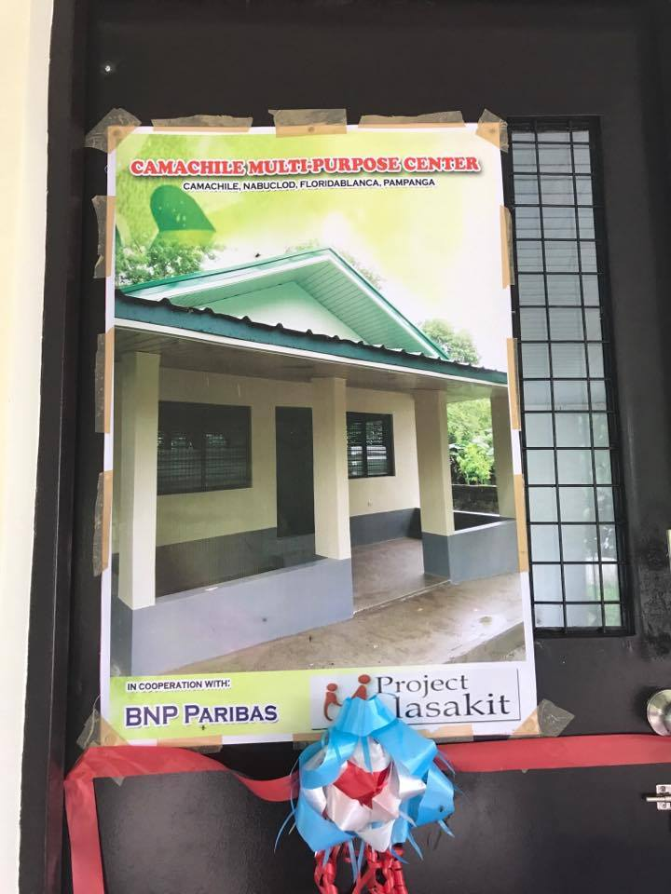 | 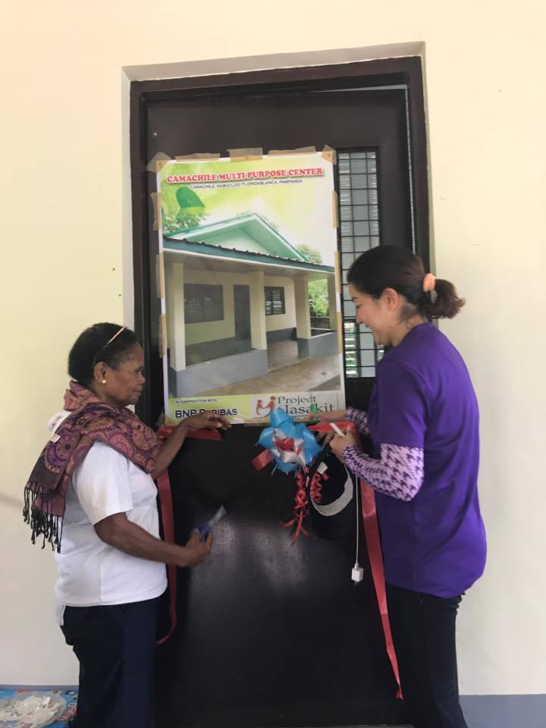

Aside from the Aeta tribe, Project Malasakit is also committed in helping the Mangyan tribe of Mindoro Province. The Mangyans are one of the poorest indigenous peoples in the island of Mindoro in the Philippines. Most Mangyan families still live in the mountains and subsist on bananas. Many mangyan children have to walk an hour or two to get to the nearest school.

Thru funds given by the Rotary Club of Walkerville in Adelaide, Australia, Project Malasakit was able to construct a Daycare and Learning Center for the Mangyan children of Sitio Kapehan, Bansud Mindoro Oriental. Potable water is also a problem in the remote mountain barangay, Project Malasakit also supervised the construction of rain water catching facilities in the community to augment the water supply of the mangyan tribe.

Electricity is likewise a problem in the remote villages of the Mangyan tribe. Because it is situated in the uplands of Mindoro province, there are no roads going to the community. Because of this, government services particularly electricity has not reached the isolated community of mangyans. Project Malasakit spearheaded in the provision of solar lighting facilities to Sitio Kapehan Brgy Rosacara Bansud Mindoro Oriental, thru the funds of Rotary Club Walkerville.

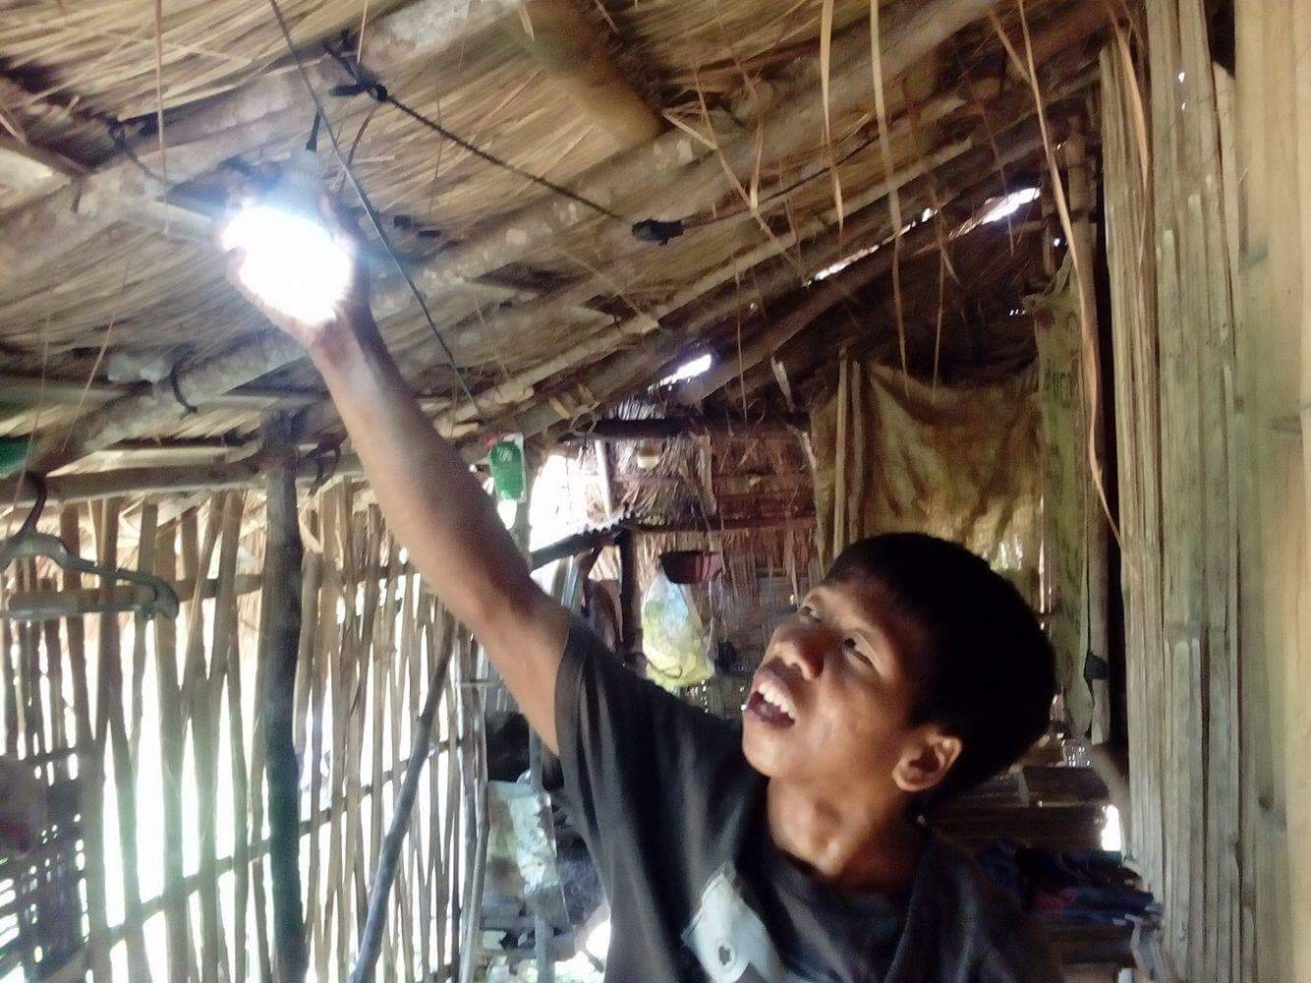 | 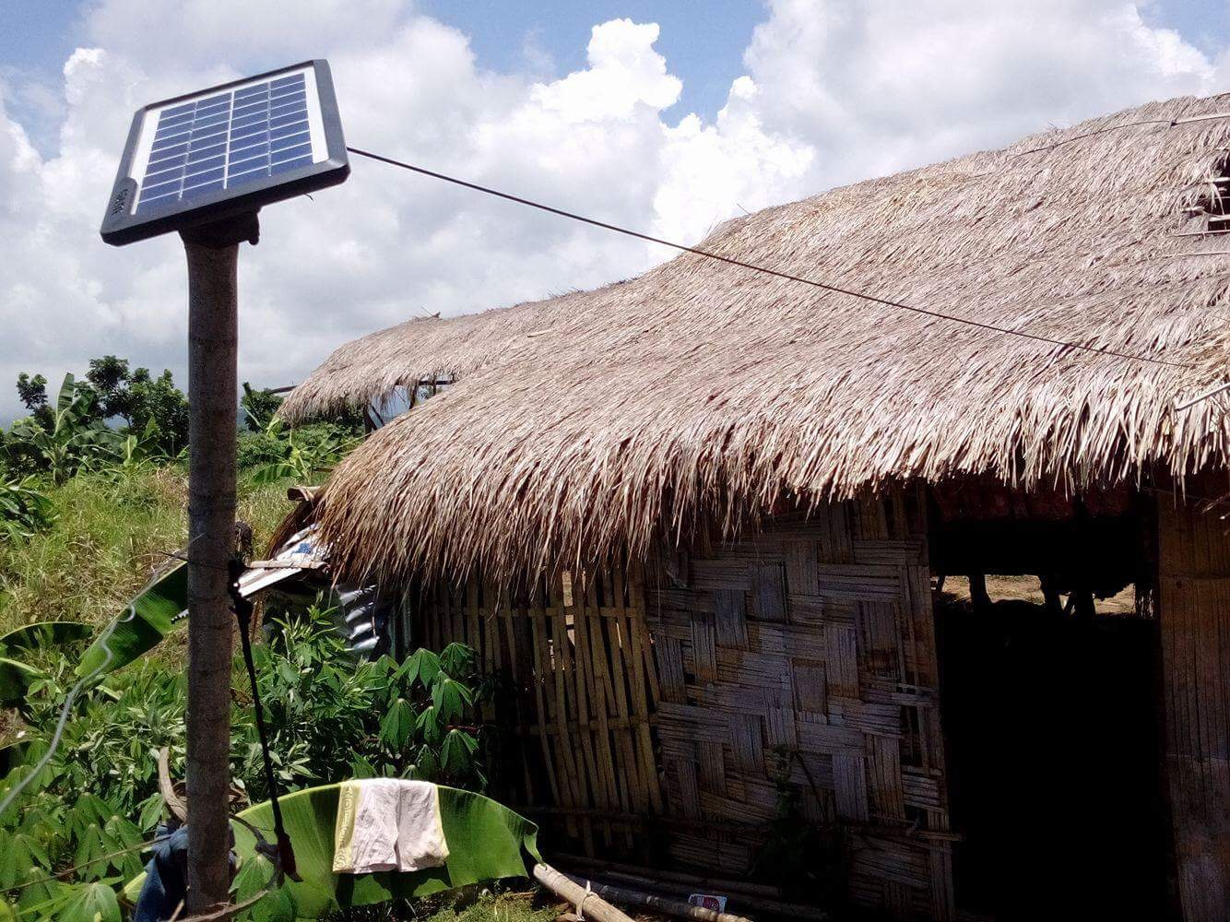
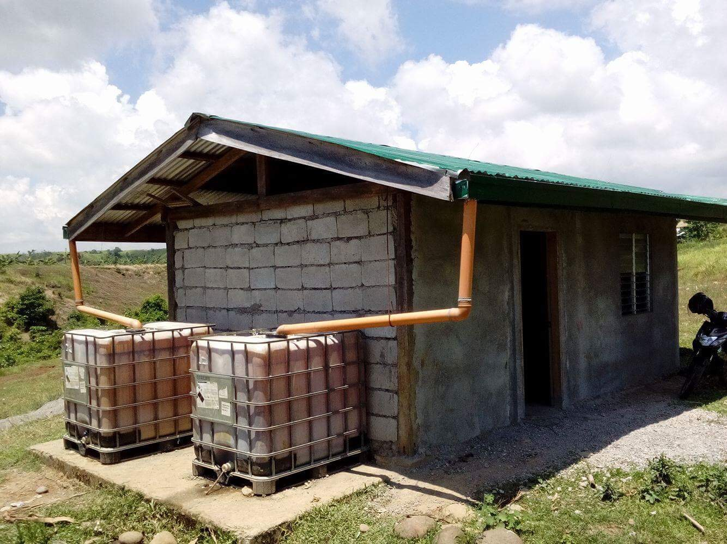 | 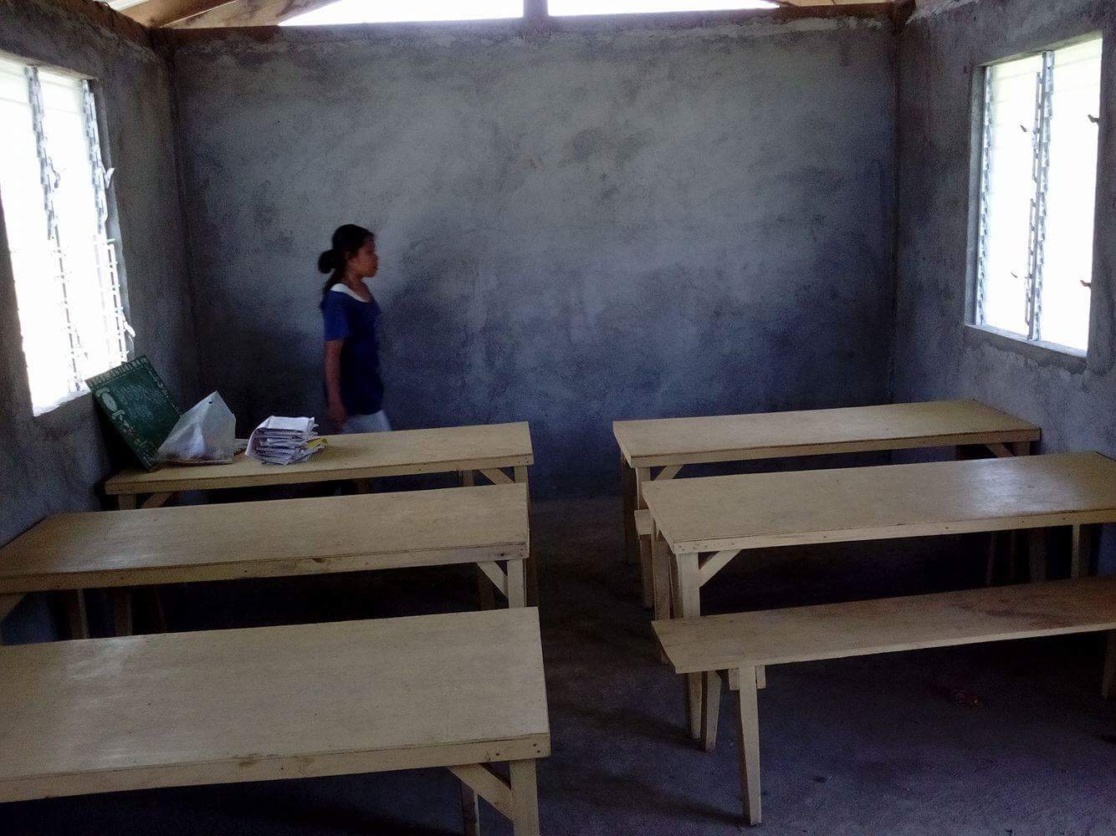

Another worthy project that we undertook in 2016 was the building of an Alternative Learning System Classroom for the Aeta Tribe in the province of Pampanga. Thru the funds given by Mr. Willie Revillame (a local TV celebrity) and Icon Engineering Inc. (an construction firm), we were able to build a modest classroom for the Adult Literacy Program of the Aetas. Many Aeta elders in Pampanga are illiterate.

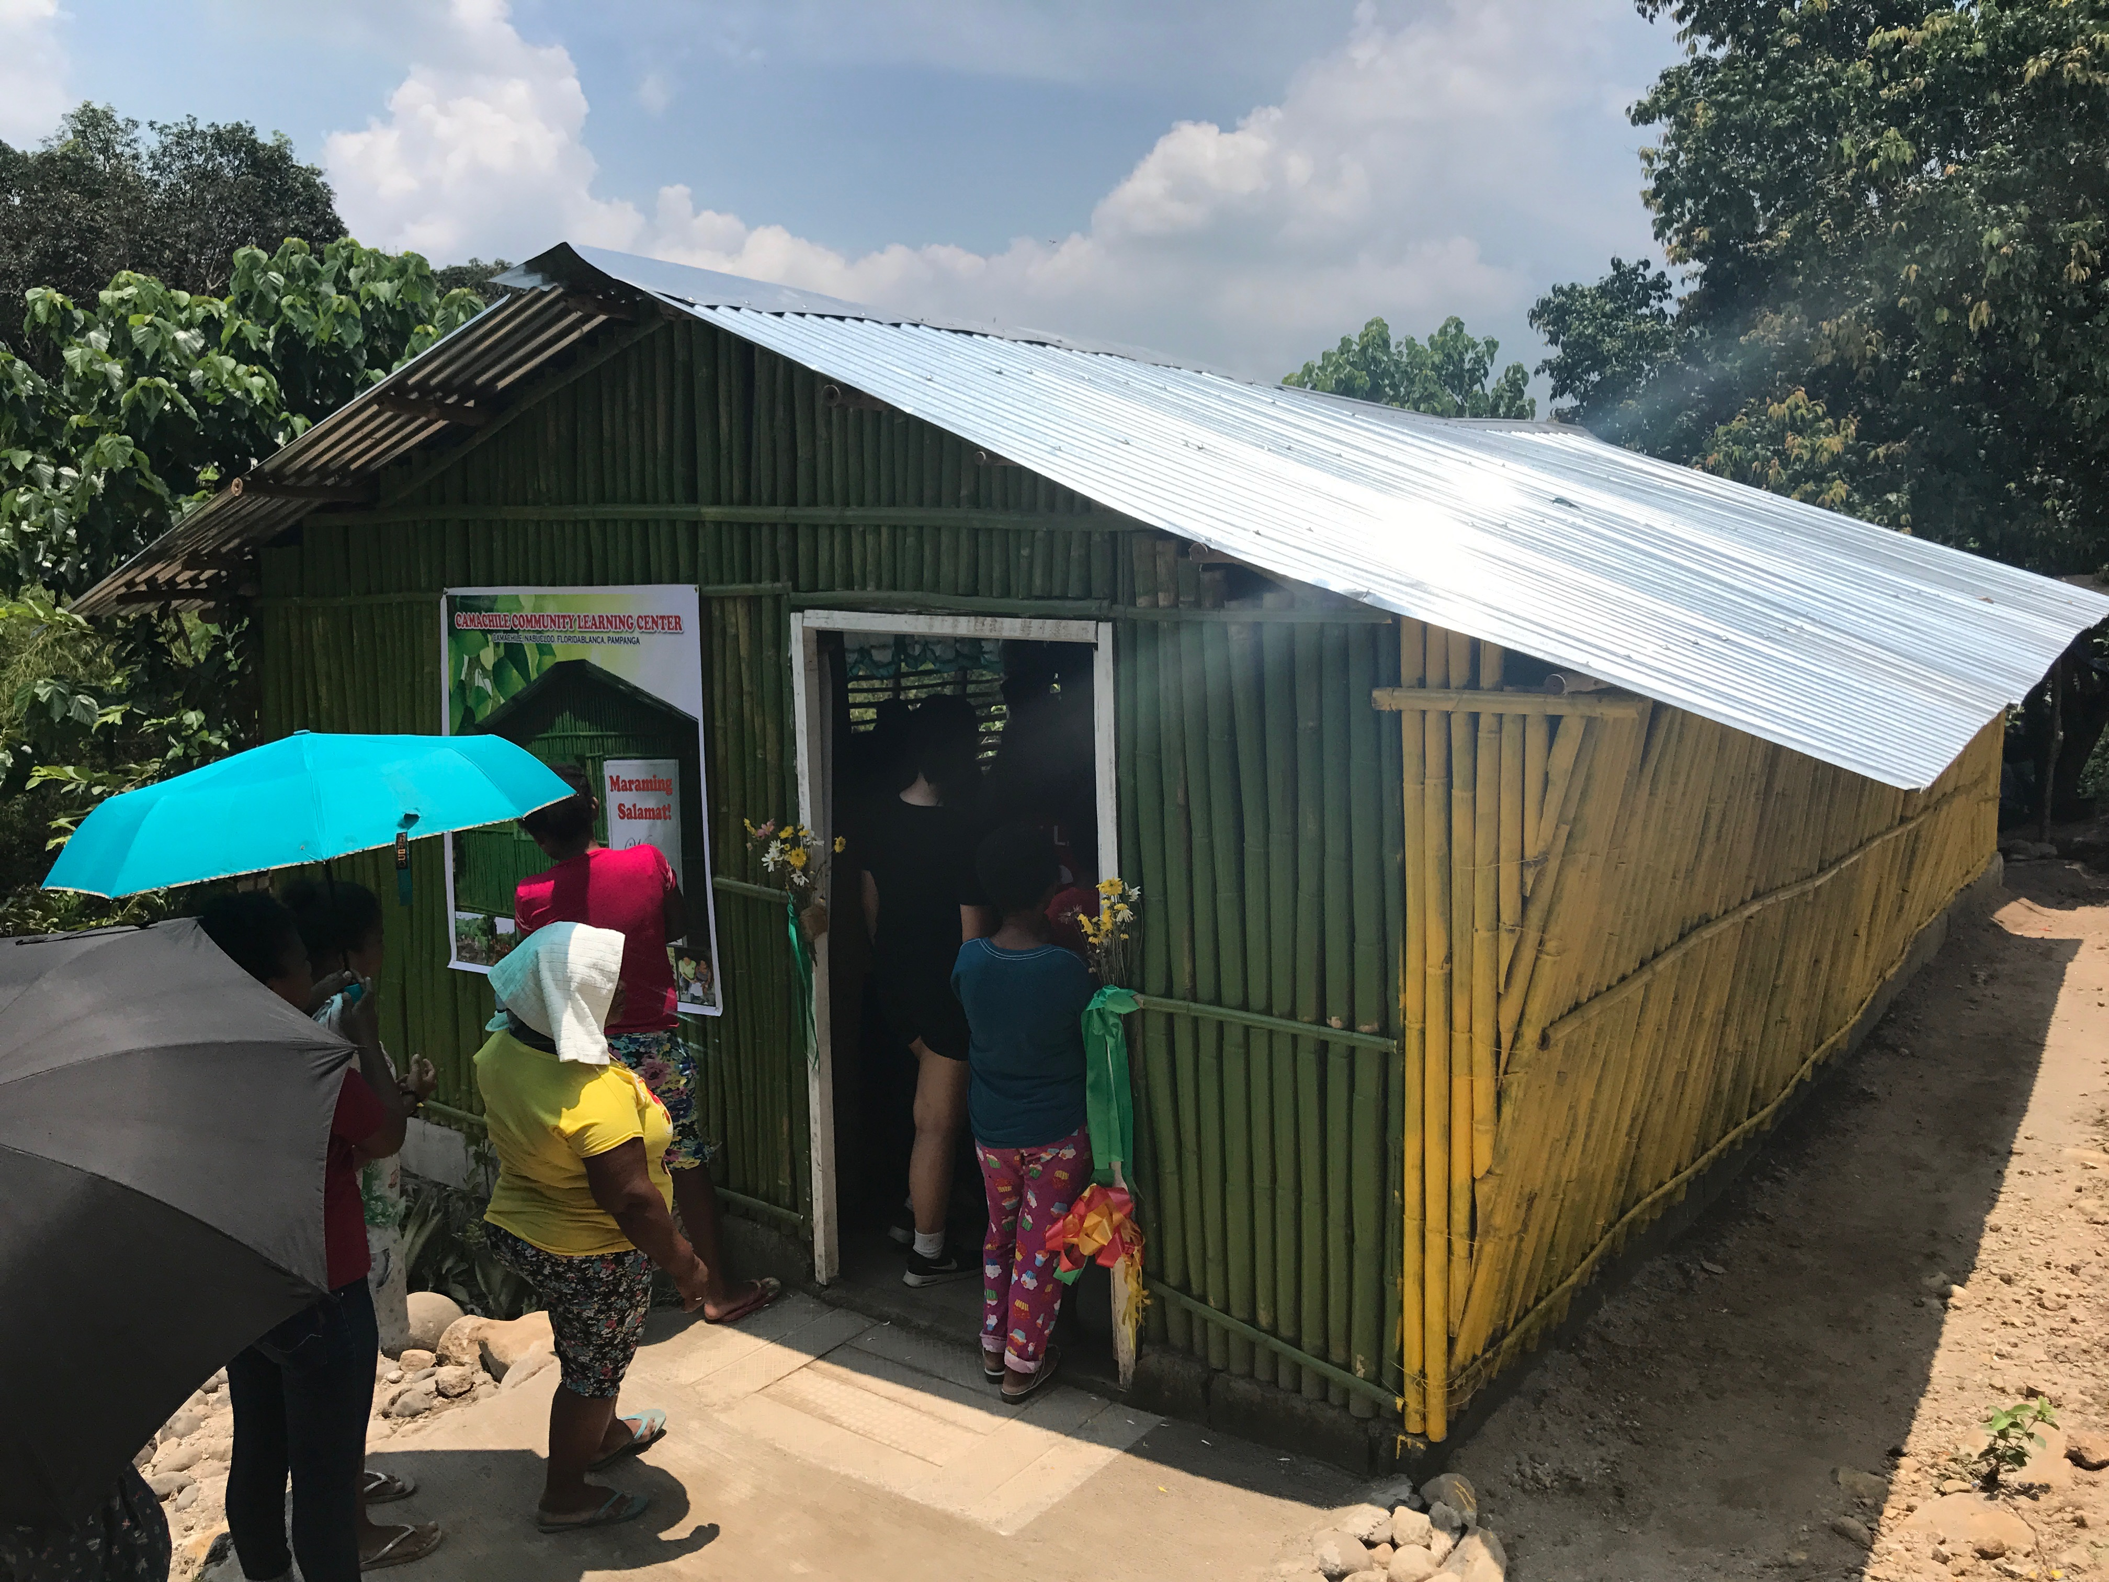 | 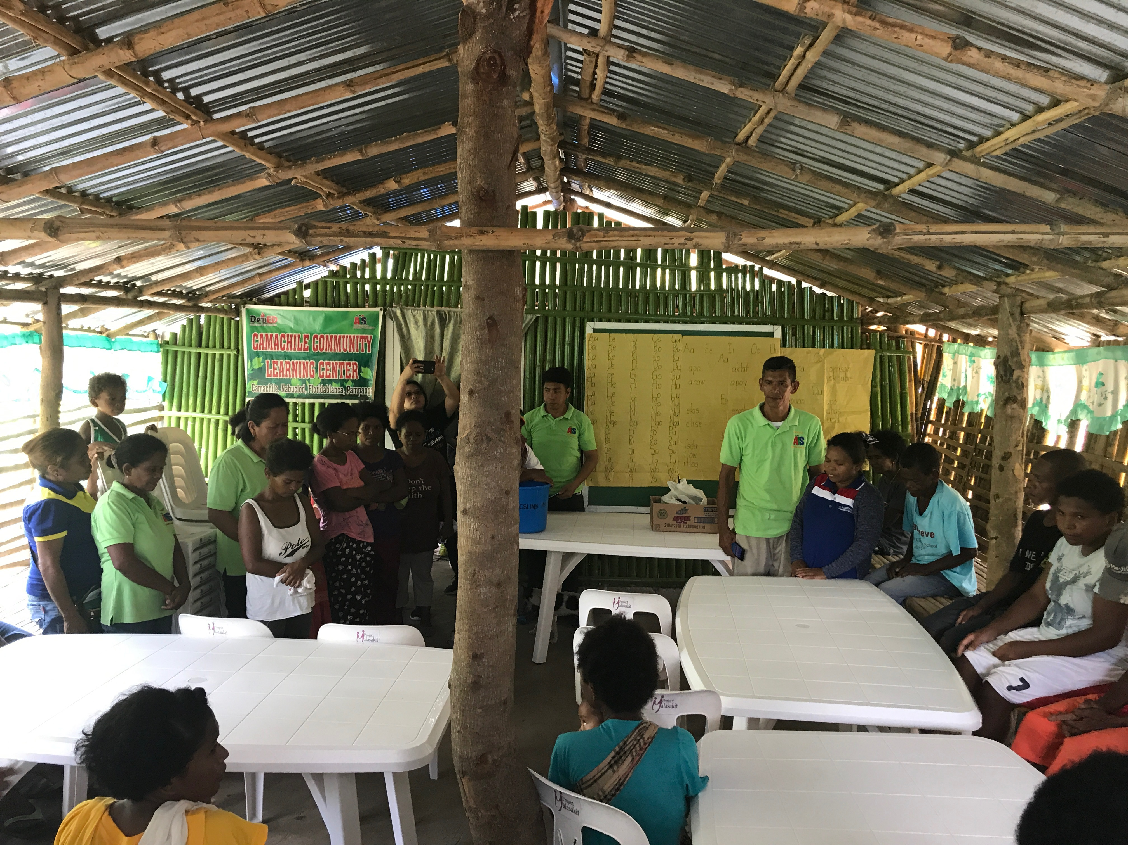

We partnered with the Department of Education (DepEd Pampanga) to construct a small school building in the mountains where Aeta elders can learn the basics of mathematics and the alphabet. The school is made of bamboo and local materials because the Aeta elders prefer to study in places that are more akin to their local culture. We have also tapped the help of Aeta volunteer teachers to teach their fellow tribe members.

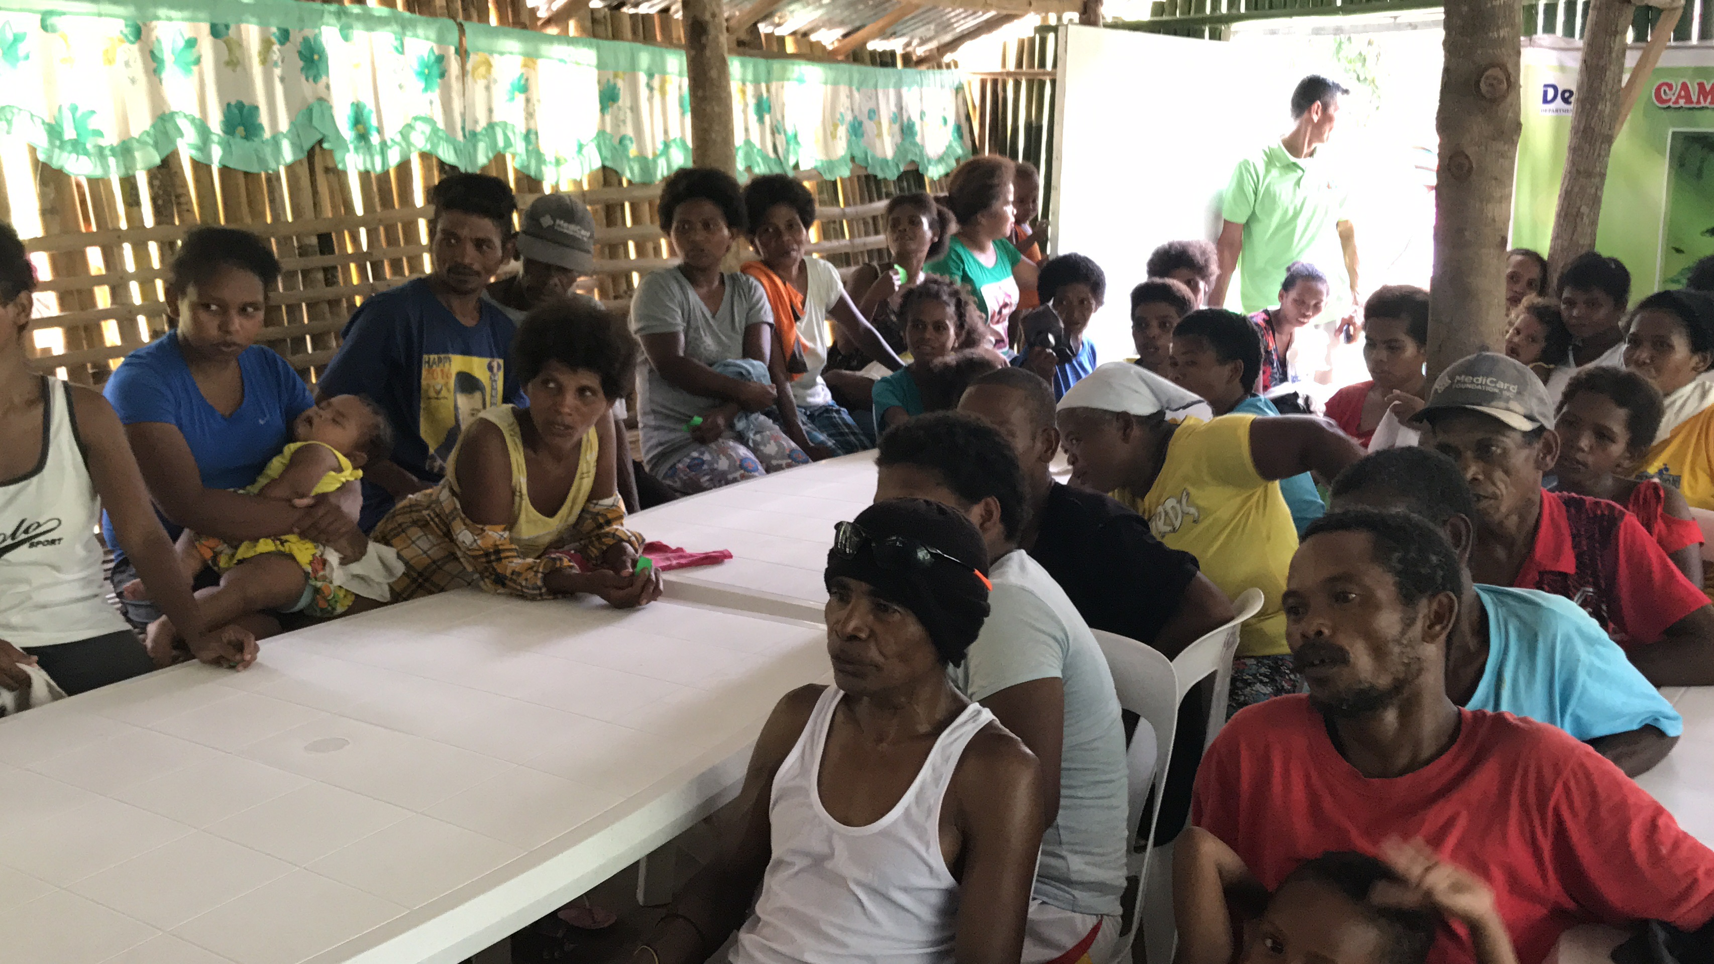 | 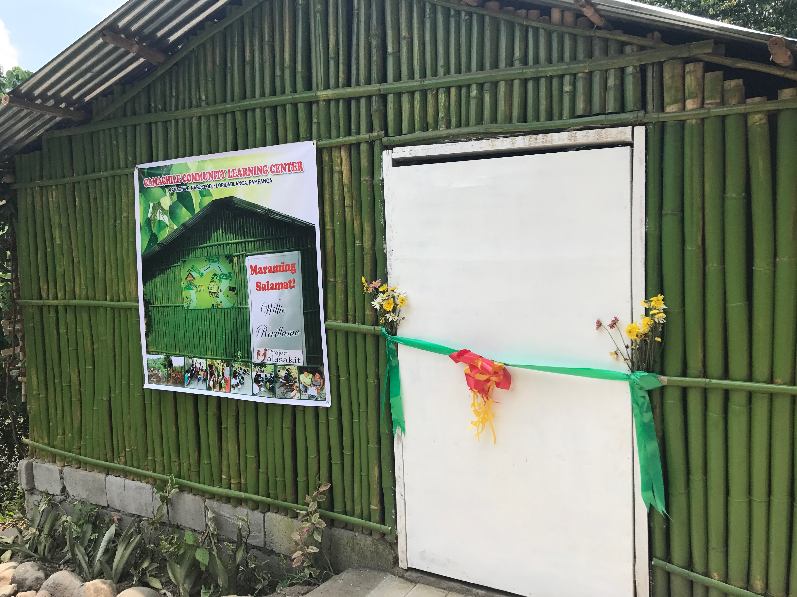

Project Malasakit also conducted several outreach activities this year for both the Mangyan and Aeta communities of Mindoro province and Central Luzon. 700 students from indigenous tribal communities were given school supplies, slippers and personal hygiene kits. We also provided their families with rice and food packs, as well as basic medicines.

2017 was also the year that the war in Marawi City in Mindanao erupted. Many children were displaced from their homes. Several NGOs set-up mobile schools in the evacuation centers. Project Malasakit worked in close coordination with some of these groups and provided school supplies to some Muslim students in Marawi who needed help.

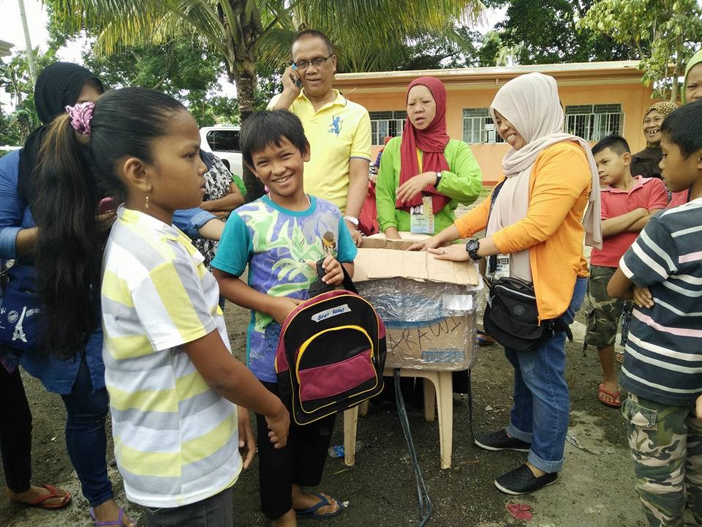 | 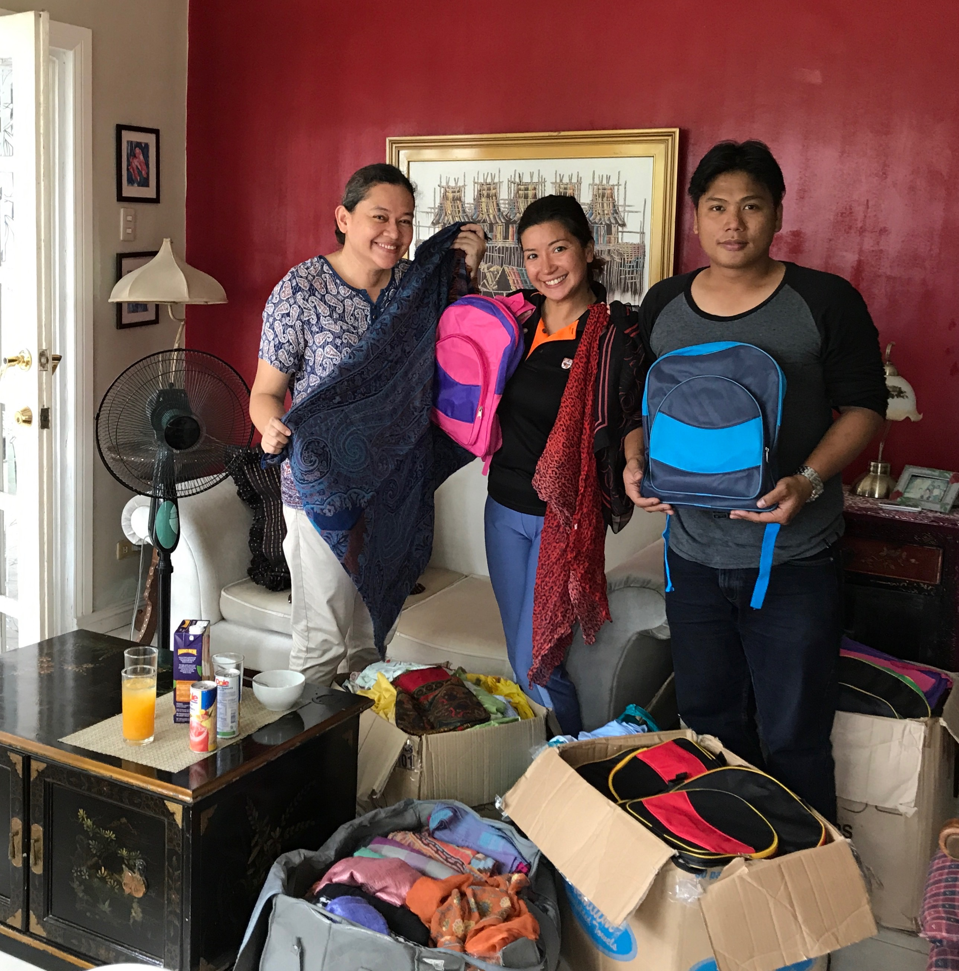

Project Malasakit's scholarship program continues to grow. For 2017, we have a total of 26 scholars (7 college level, 10 high school level, 9 elementary grade). We have three new scholars: a bright and hardworking Muslim girl from war-torn Lanao del Sur in Mindanao (Ryanessa Amerol); a very talented young artist who used to live in the slums of Manila (Christian Dayo) who is now taking up Fine Arts; and a hardworking young man who has been a child laborer all his life in Aklan province (Christian Colas).

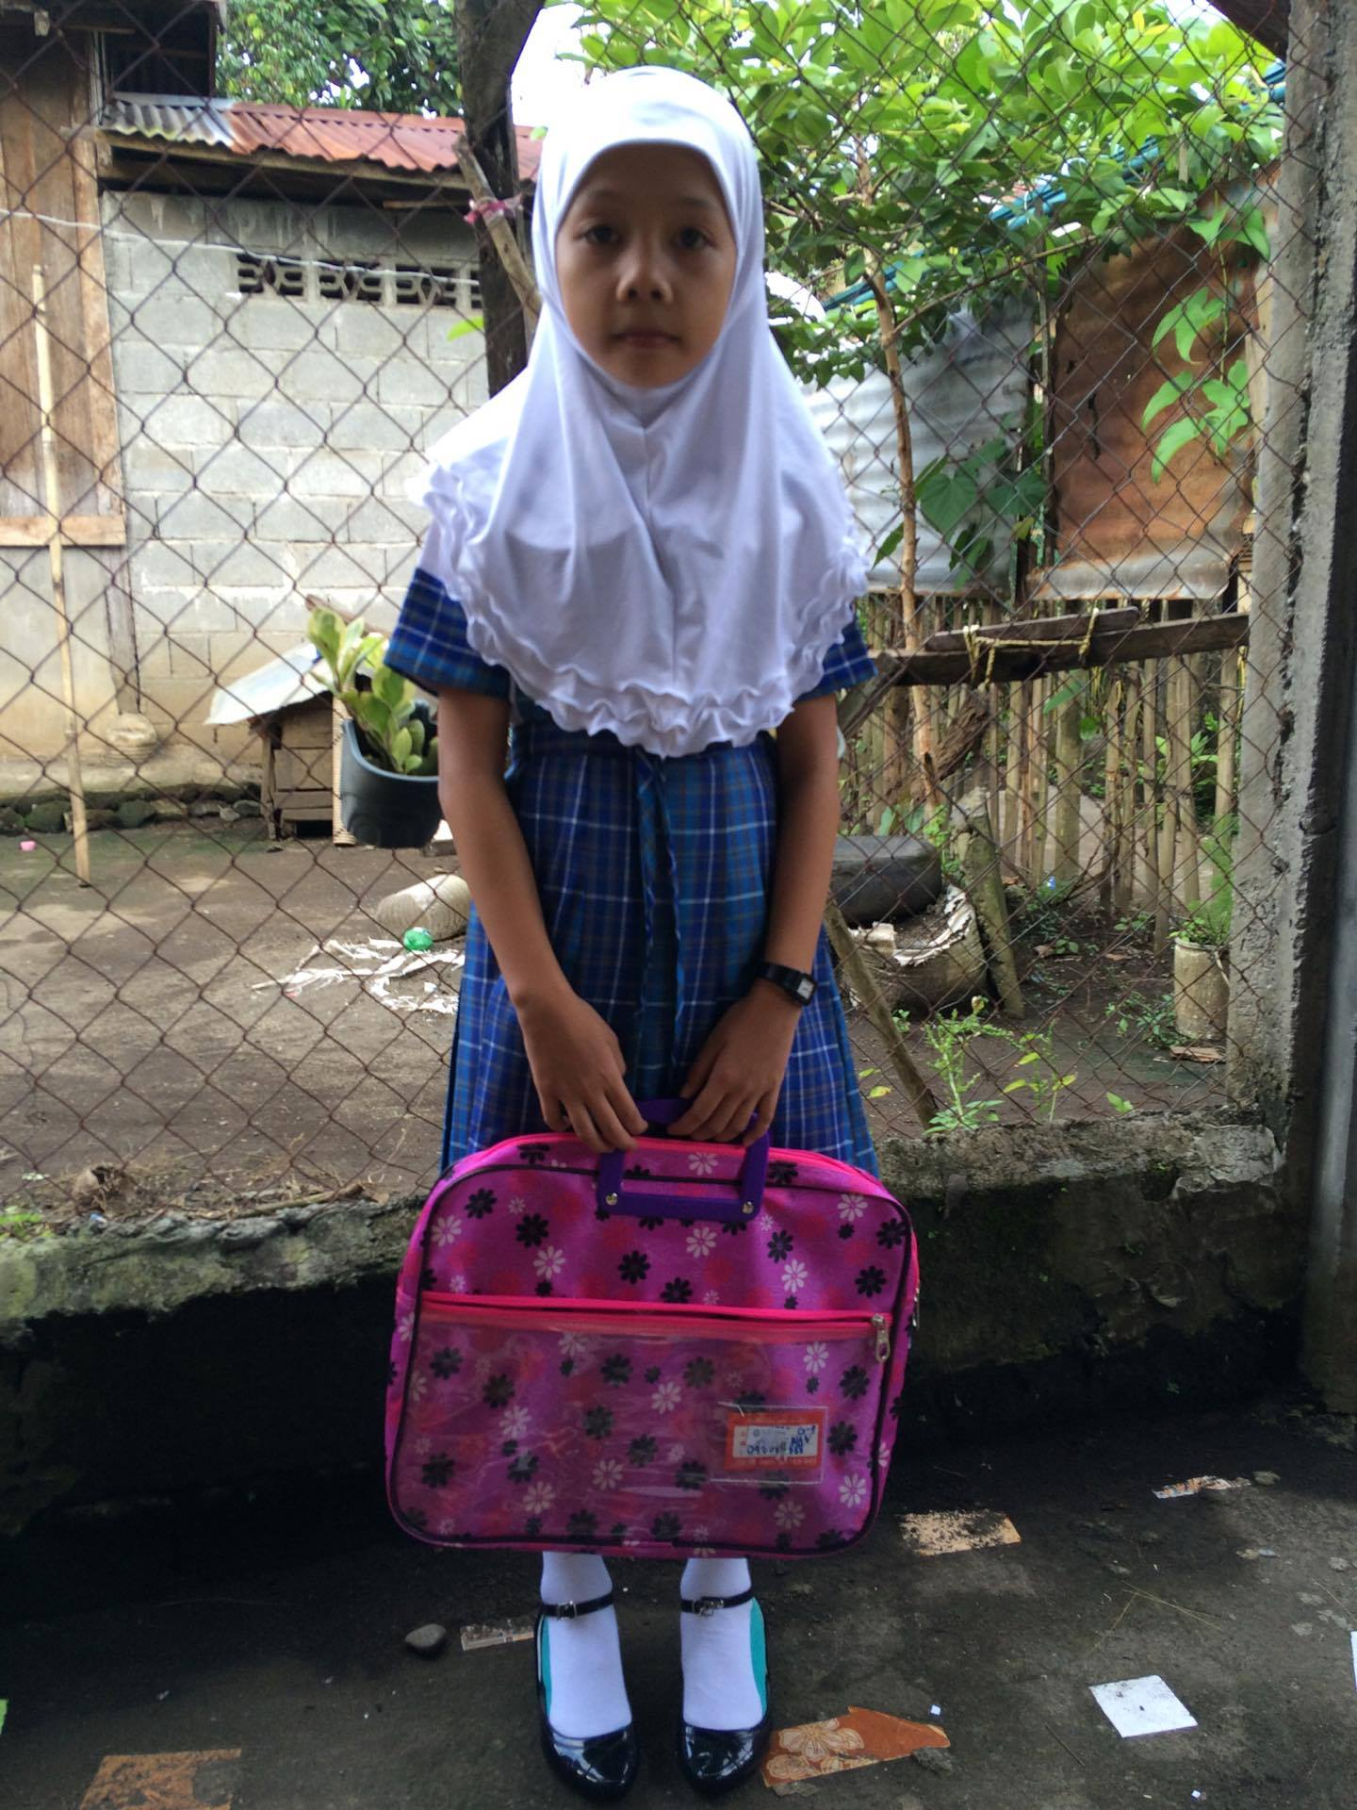 | 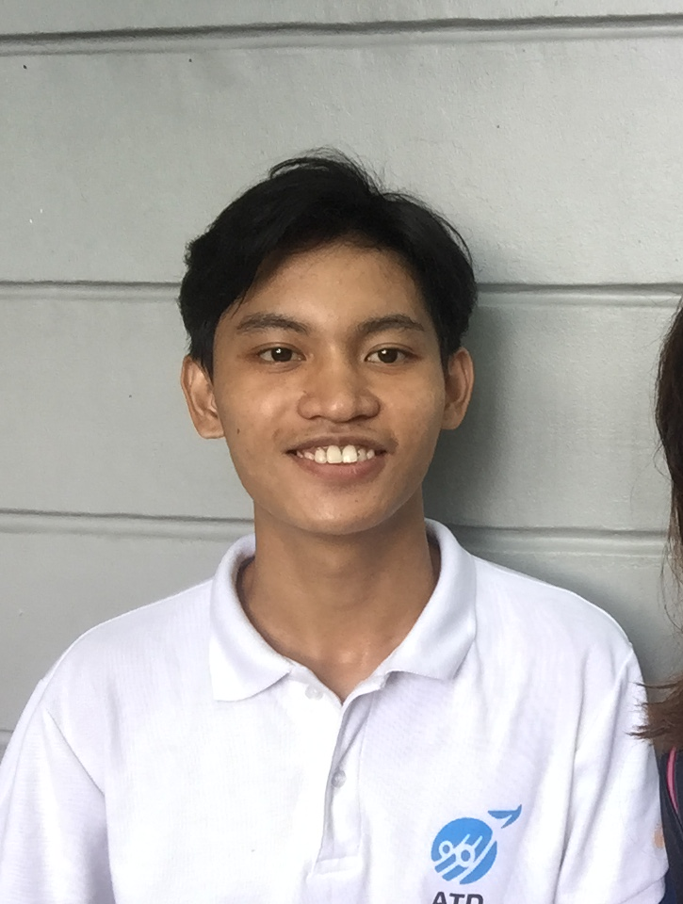

We are also very proud to report that one of our most hardworking scholars Joselito Padilla, has successfully graduated from college. Joselito has been our scholar since he was in Grade 4. Joselito was a former child laborer since he was 9 years old. He used to dive for sea urchins to earn a living and send himself to school. Project Malasakit fully supported his scholarship. And after 10 years, Joselito has finally graduated from college with a degree in BS Marine Transport. We are currently helping Joselito with his papers as a seafarer. He is currently in Manila taking up various training activities before he can formally work in the large maritime companies.

Summary of Projects Undertaken:
- Construction of Health Center for Aetas (Pampanga)
- Construction of Community Learning Center for Aeta (Pampanga)
- Construction of Daycare Center for Mangyan children (Mindoro)
- Construction of Rain Water Catching Facility (Mindoro)
- Distribution of Solar Lighting Facilities for Mangyans (Sitio Kapehan, Mindoro)

Outreach Programs Undertaken:
- Distribution of groceries for 100 Aeta Families (sitio camachile) (January)
- Distribution of school supplies for 100 Aeta students (January) sitio camachile
- Distribution of school supplies for 100 Mangyan students (March) sitio kapehan
- Distribution of school supplies for 200 Aeta students (April) brgy camias
- Distribution of school supplies for 75 Muslim students in Marawi (June)
- Distribution of groceries for 50 Aeta families (August) Sitio Camachile
- Distribution of school supplies for 200 Aeta children (August) Sitio Pabanlag
- Distribution of groceries for 100 Aeta families (August) Inararo, Porac, Pampanga
- Distribution of school supplies 100 Aeta children (August) Porac Pampanga

Scholarship Program (total of 26 scholars)
Scholars in Elementary Level
- Ryanessa Amerol
- Redentor Chavez
San Isidro Elementary School, Palanan, Isabela
- Lynlyn Cuevo
Osmena Elementary School, Jose Panganiban, Camarines Norte
- Omnia Ebrahim
Felix Panganiban Elementary School, Lanao del Sur
- Mauwe Liwanag
Batiawan Integrated School, Subic, Zambales
- Joshua Manoblahan
Kalilig Elementary School, Agusan del Sur
- Dizza Venancio
Espana Elementary School, Sibuyan, Romblon
- James Venancio
Espana Elementary School, Sibuyan, Romblon
- JR Venancio
Espana Elementary School, Sibuyan, Romblon

Scholars in High School Level
- Edrian Bangngayen
Jose Manzano National High School, Tuy, Batangas
- Eric Blaza
Bernos Memorial High School, Bangued, Abra
- Bimiana Capuno
Planas High School, Porac, Pampanga
- Anthony Dado-Acon
Leyte Colleges, Tacloban City, Leyte
- Karen Liwanag
Batiawan Integrated School, Subic, Zambales
- Sajarah Jean Morales
Rizwoods Colleges, Lapu-Lapu City, Cebu
- Eleazar Pido Nacua
Sta. Rosa National High School, Cebu
- Kevin Nacua
Sta. Rosa National High School, Cebu
- Jennifer Sotto
Batiawan Integrated School, Subic, Zambales
- Christian Colas (Aklan)
Grade 11 at Brgy. Dalagasan Libacao, Aklan

Scholars in College Level
- Charlie Bangngayen
BS Criminology, Batangas State University-Arasof
- Losalin Dimaano
BS Education, Luna Goco Colleges, Mindoro
- Charls Bryan Katipunan (Manila)
BS Accountancy, Far Eastern University, Manila
- Joselito Padilla (Pangasinan)
BS Marine Transport, PIMSAT Colleges, Dagupan
- Philip Christian Palabay (Leyte)
BS Accountancy, University of the Philippines, Tacloban
- Patrick Reyes (Mindoro)
BS Education major in Math, Innovative College of Science & Technology, Mindoro
- Christian Dayo (Manila)
BS Fine Arts, Eulogio Amang Rodriguez Institute of Science & Technology (EARIST), Manila

